Calendar Day Change

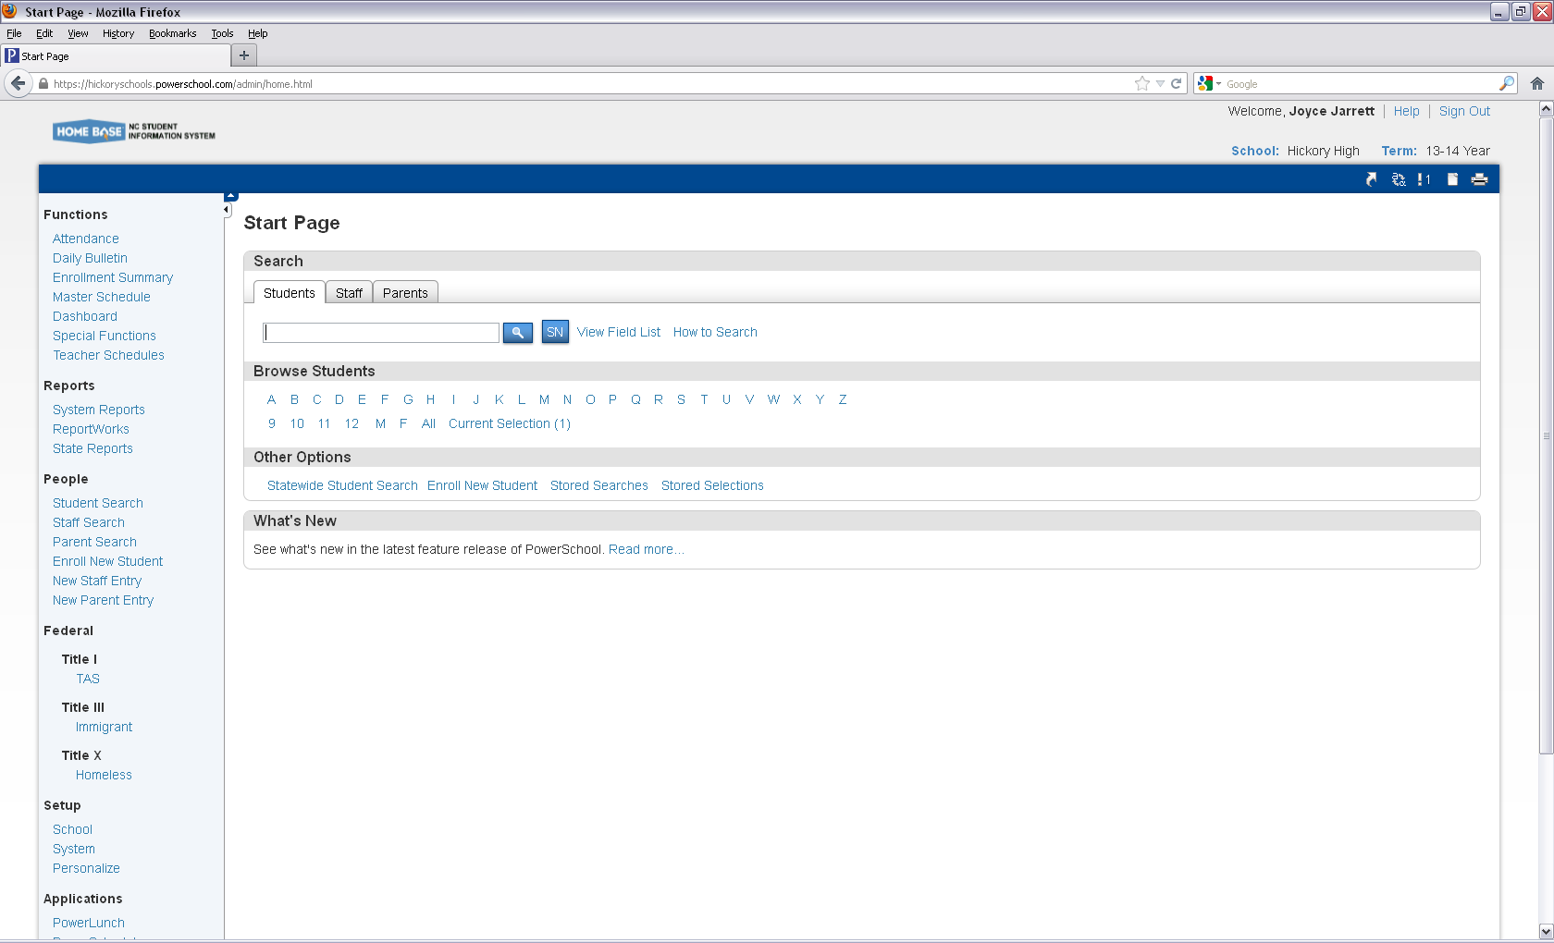

Main Page

Setup

School

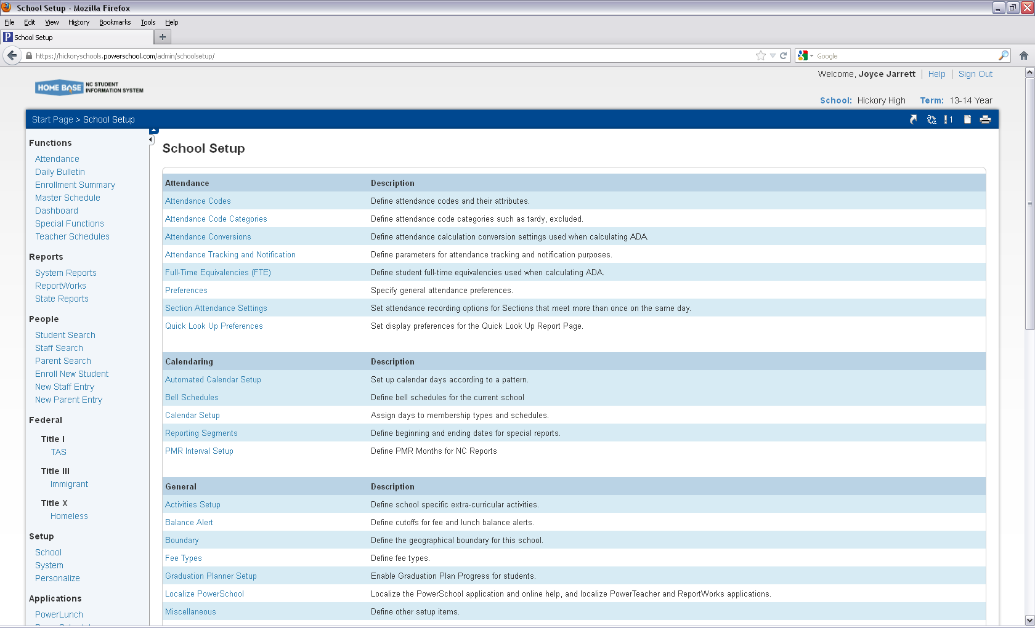

Calendaring

Calendar Setup

Calendar Setup

Click on the month you will be changing.

Example 01/14

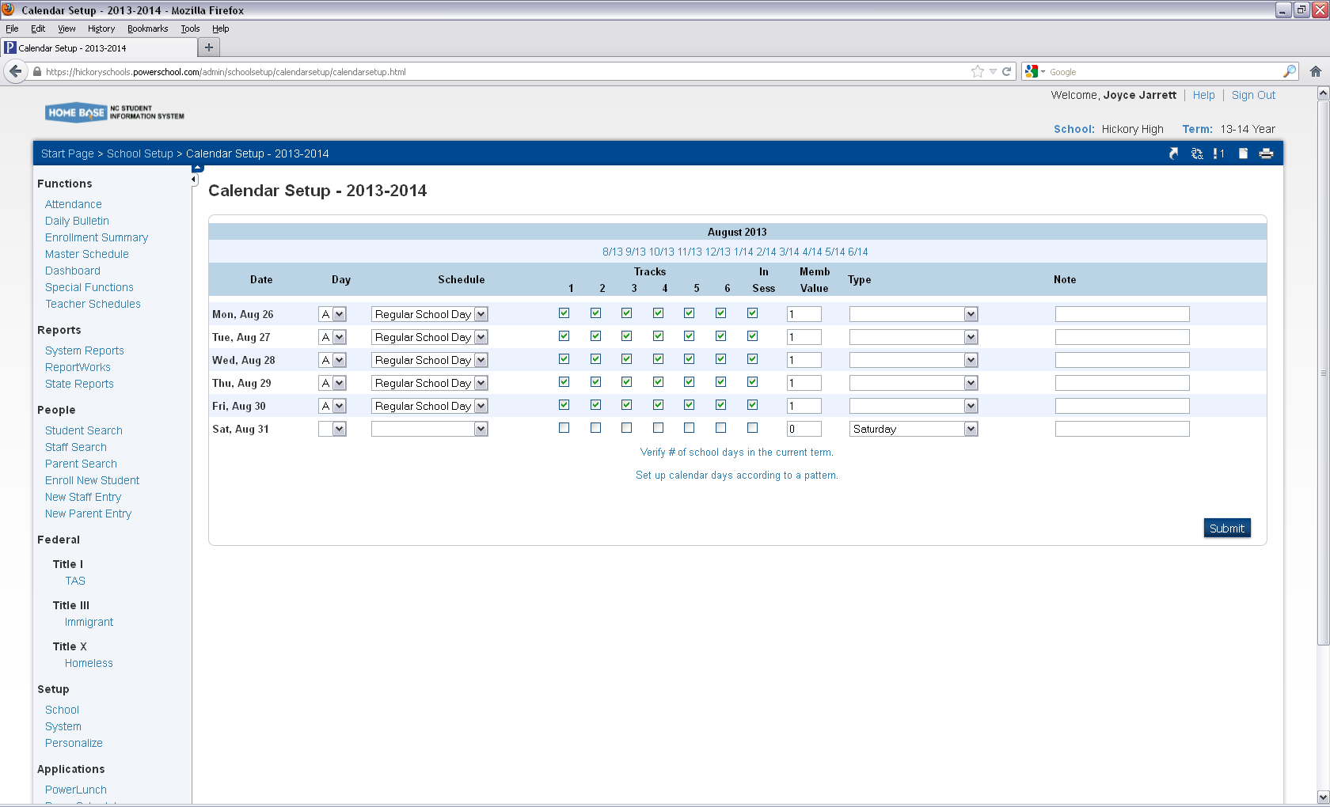

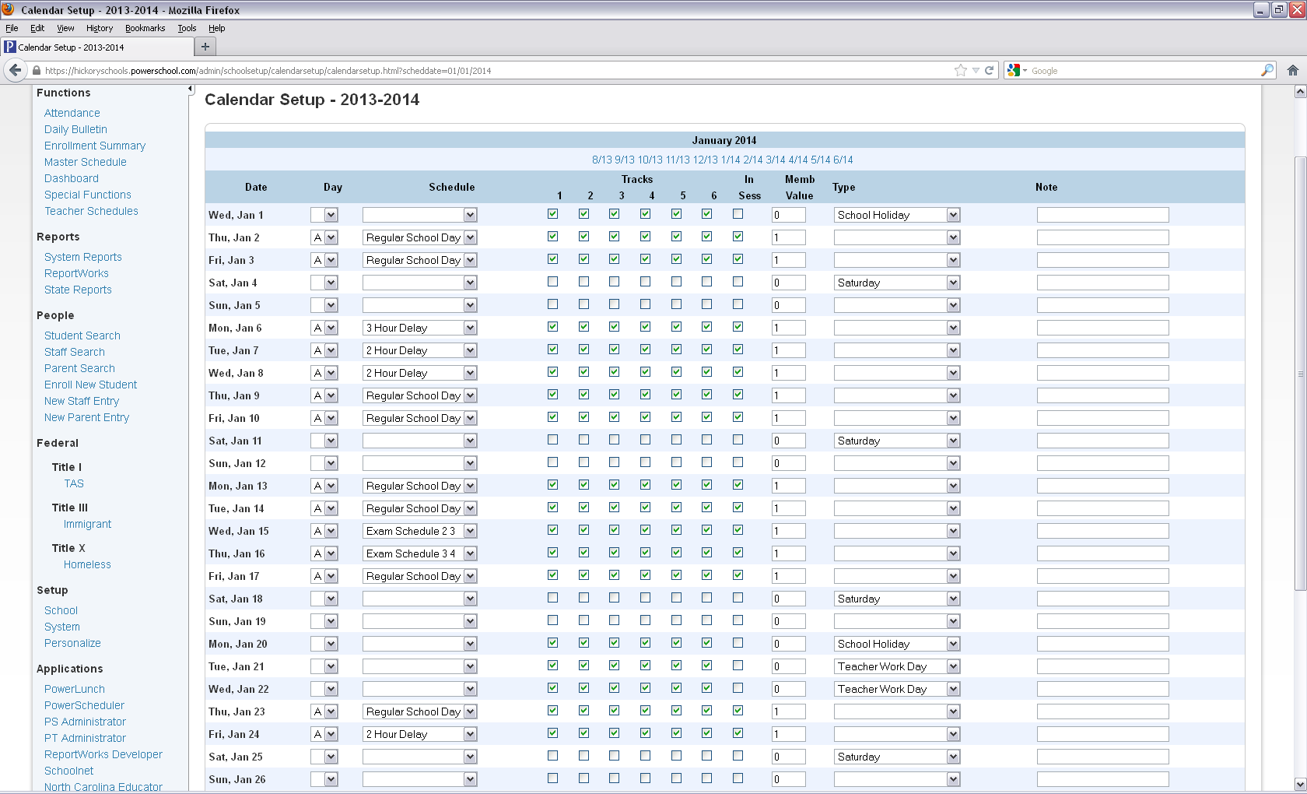

Find the Date you need to change.

Look at the top screen this is

Day not date change to a blank with the drop down.

Change the Schedule to blank with the drop down.

Uncheck all the tracks.

Change the in session to 0

Change the Type to weather closure or whatever the system decides.

Submit

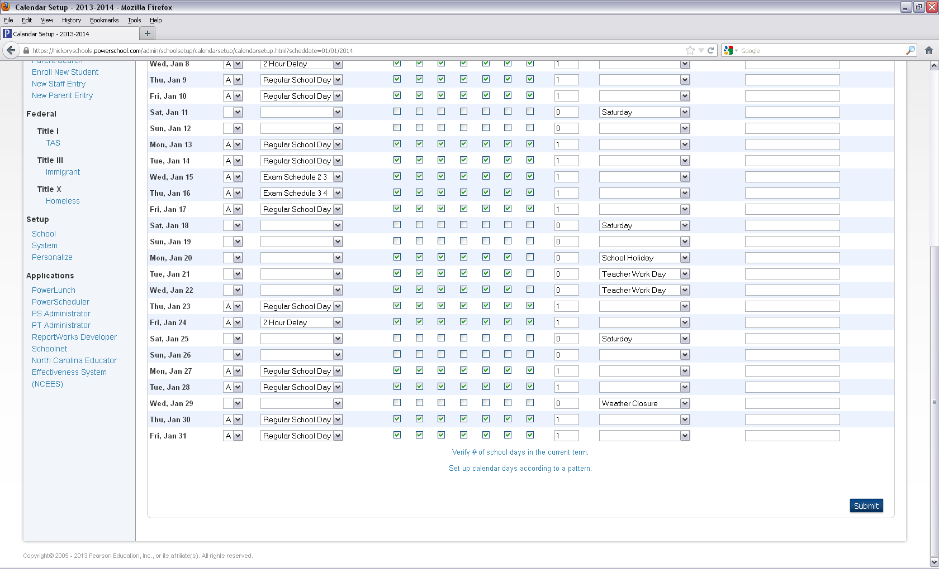

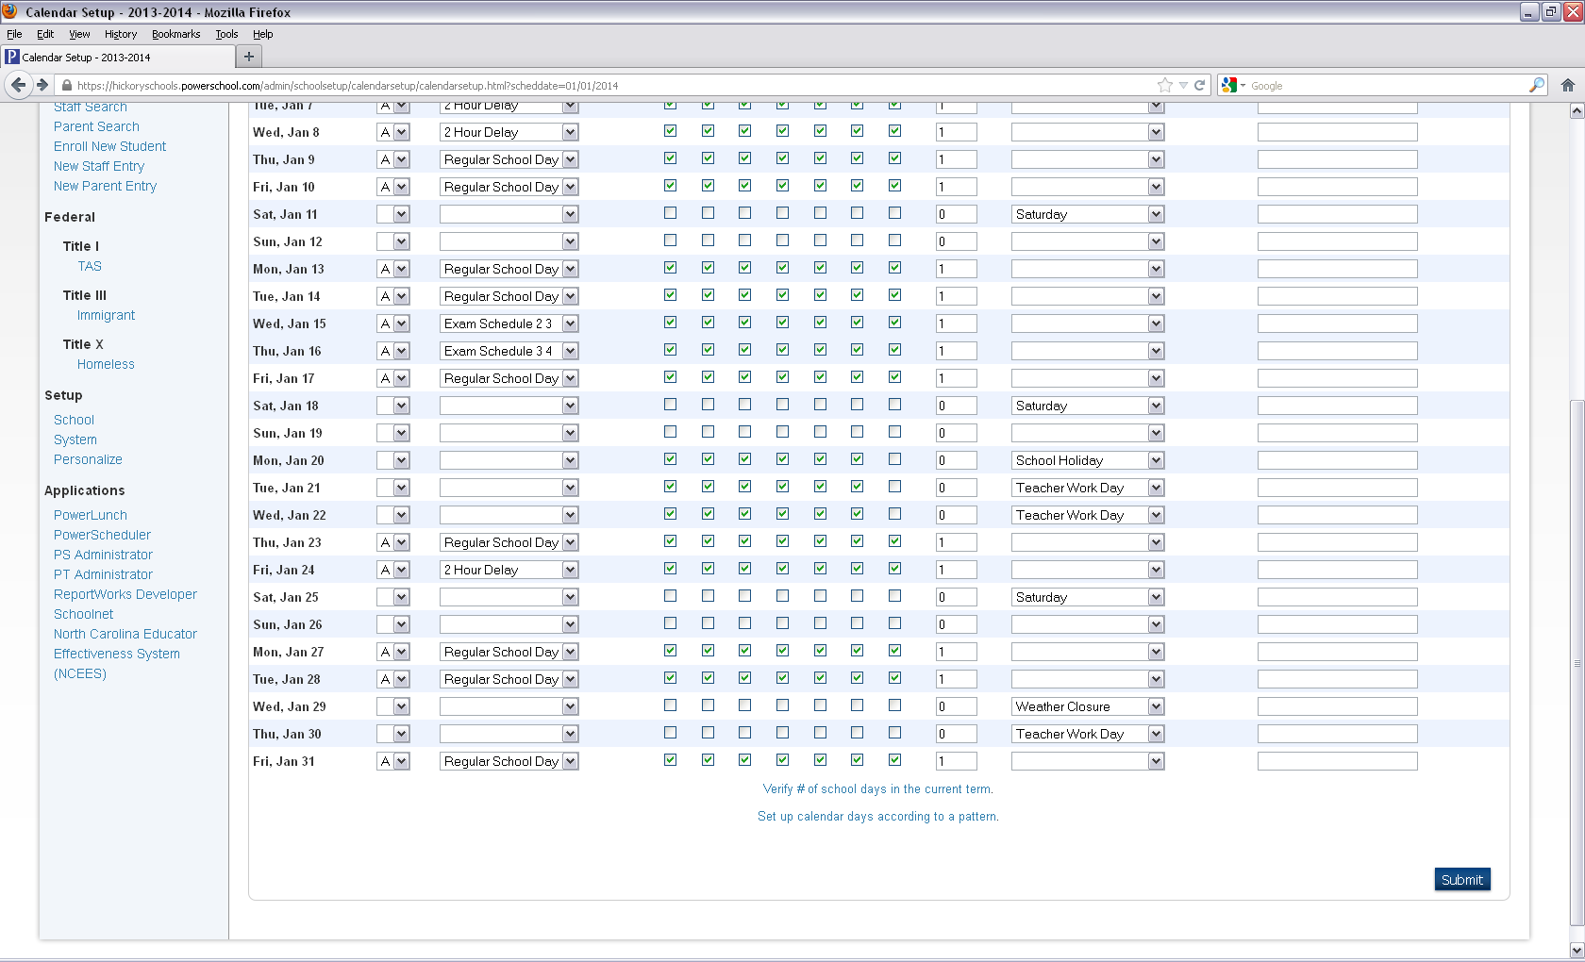

At this point please do not add in the days we will use for the closures.

Power school will need to have some major and minor adjustments and some may need to be

Fixed at night.