End of Nine Weeks Directions for Teachers
Once all assignments for the nine weeks have been entered, teachers can enter comments for the end of term mark Q1, Q2, Q3, or Q4.
Teachers should double click on the Q1, Q2, Q3, or Q4 final grade box to enter a Teacher comment.
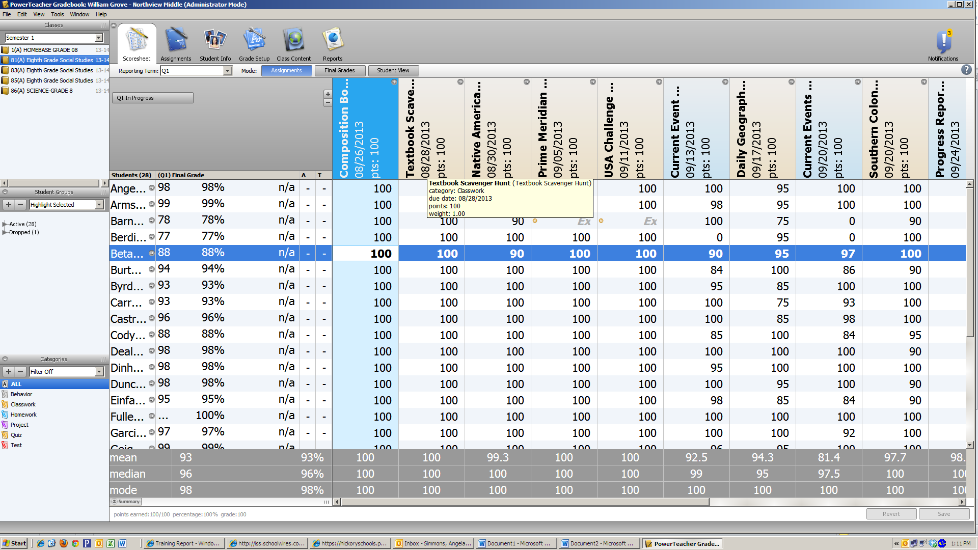
A new box will pop-up for you to select a comment. The top of the box will have the student name. You can move through the student names by clicking on the arrow. Be sure the tab “Comment” is showing.

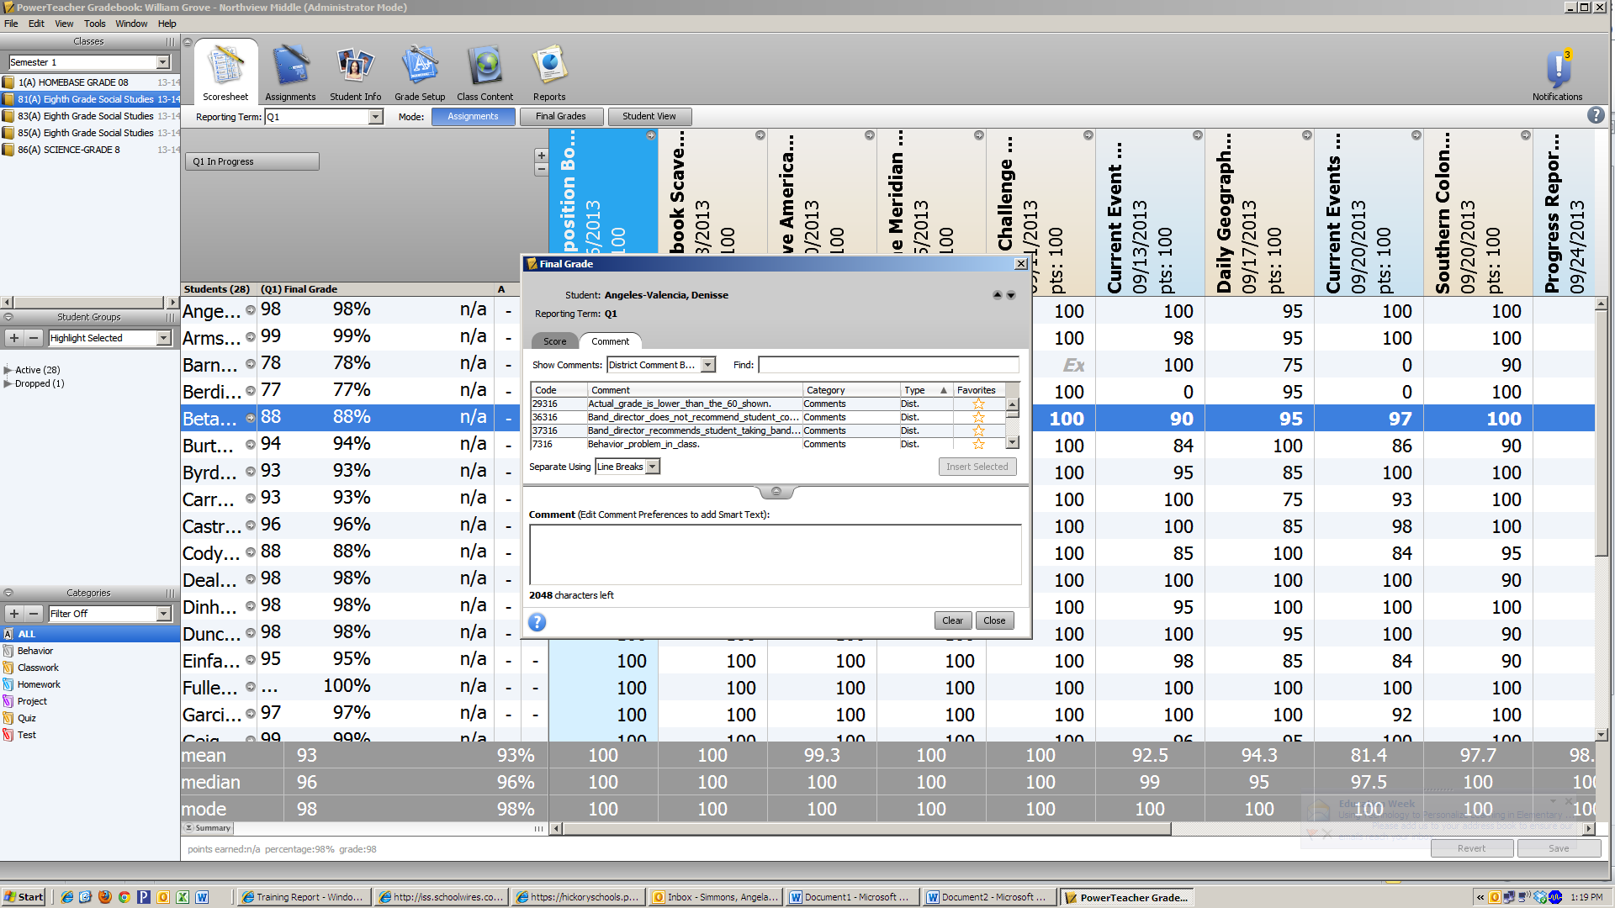
Scroll to select the comment for the student. Click insert selected.

Click here to switch students.
Click close when finished.
Once all grades and comments are finalized, the teacher will click on the Q1 (2,3, or 4) In Progress button.
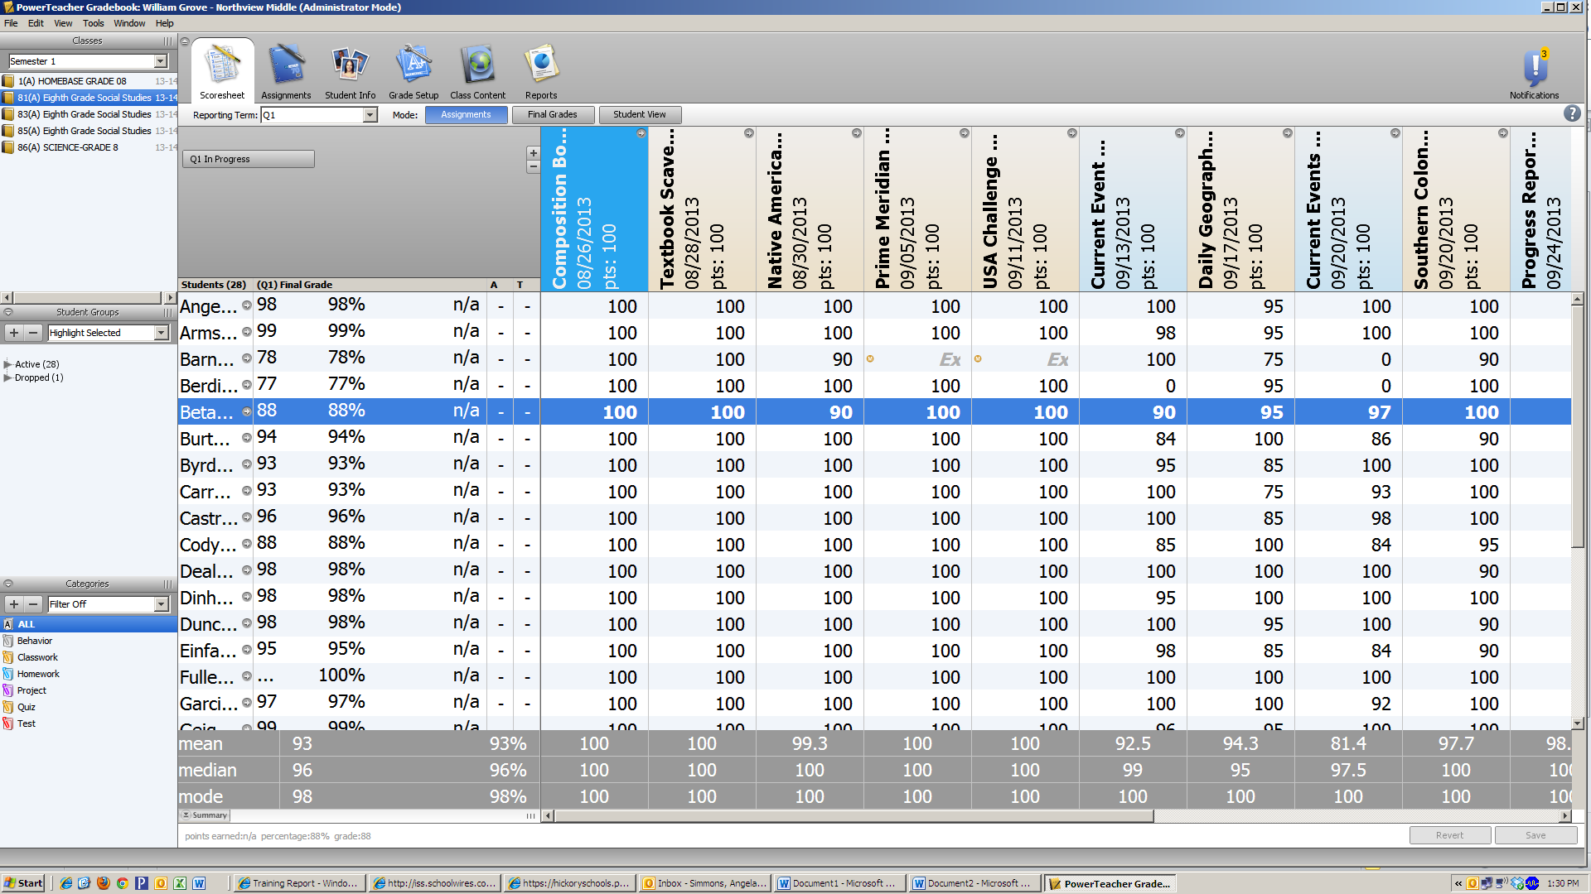

A new box will pop-up for the teacher to enter the date and time grades are completed. The teacher will also check the “Final Grade Complete:” box.
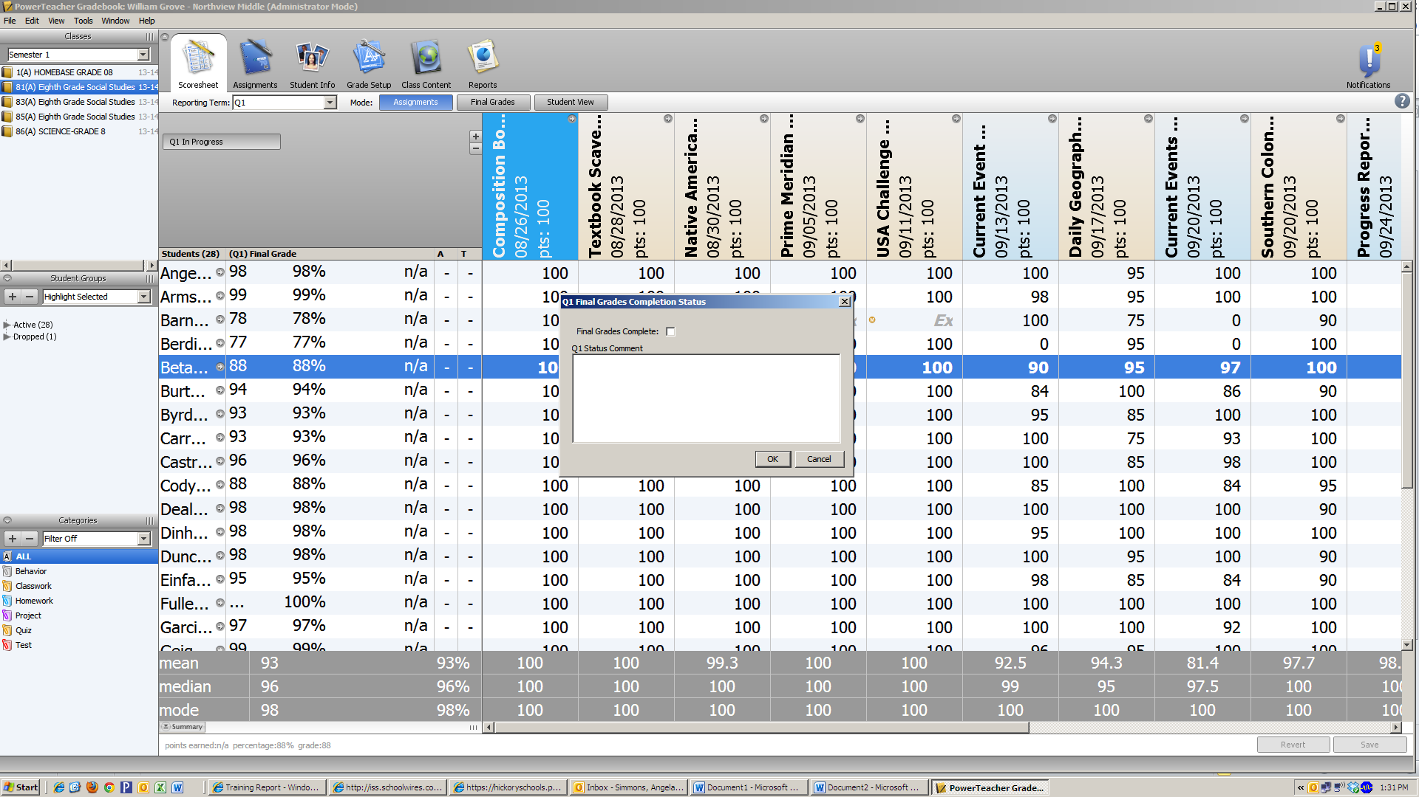
Enter the date and time grades are completed.
The teacher will print a report called Final Grade and Comment Verification, sign, and submit a copy to the data manager.
Once the next nine weeks begins, be sure the reporting term is on Q2, 3 or 4 as appropriate.
*****If any grades or attendance needs to be changed after Data Manager prints report cards, the teacher must notify the Data Manager and make the change in the grade book.*****

