Attendance Count Report

1 Choose all students or grade.

2 System Reports

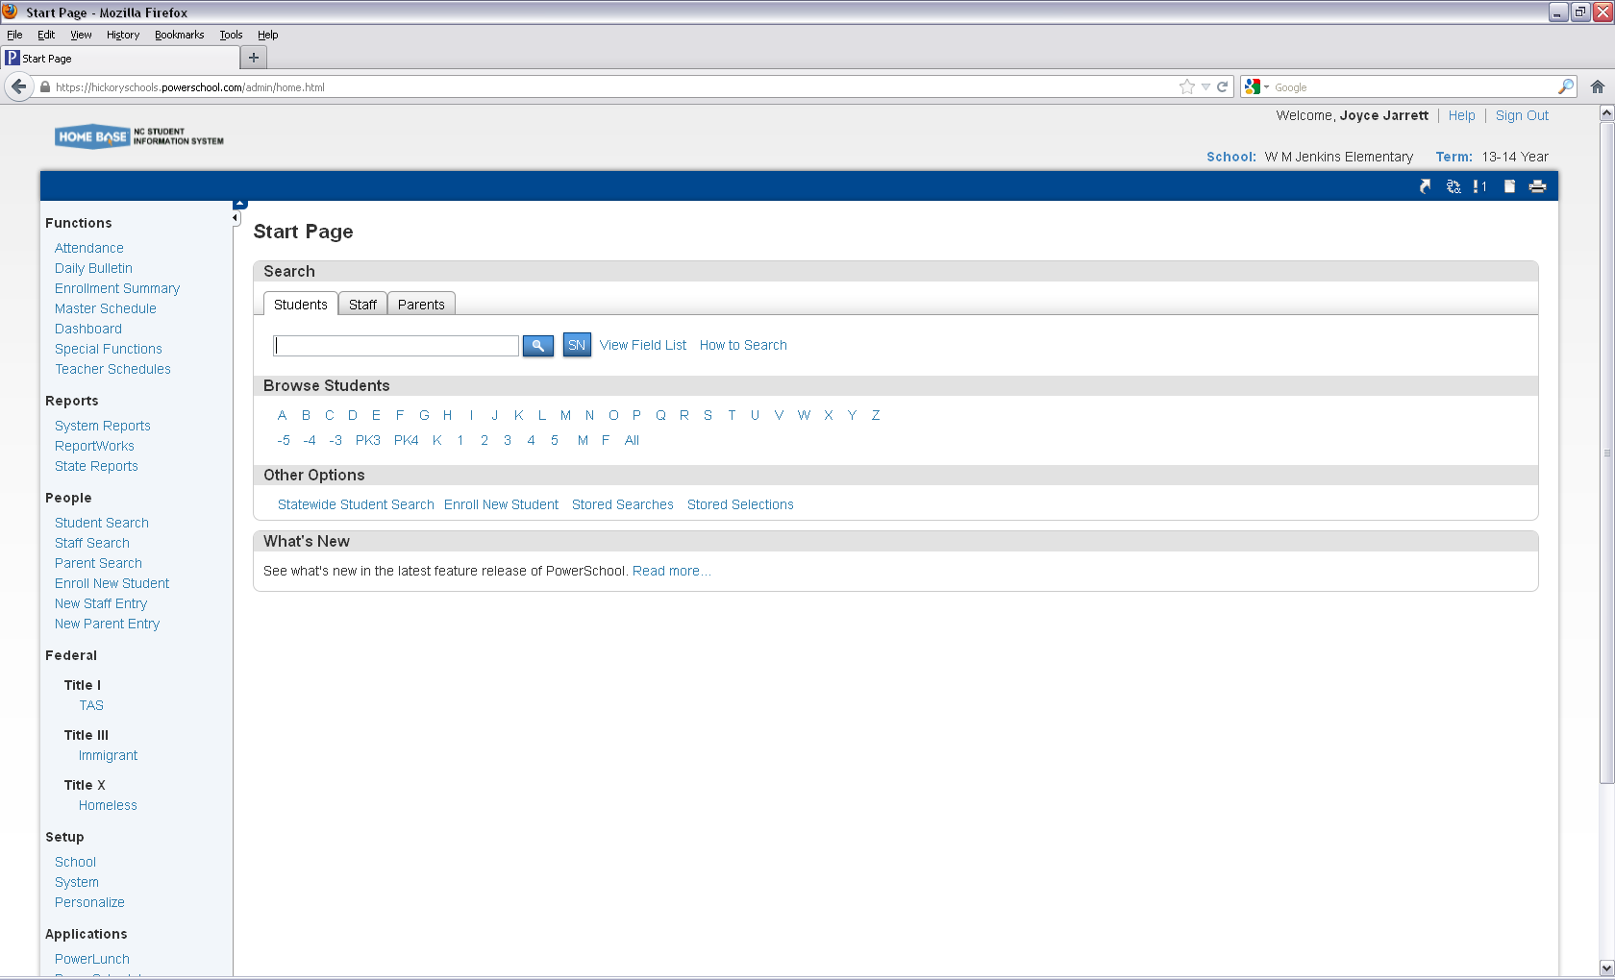

2

1

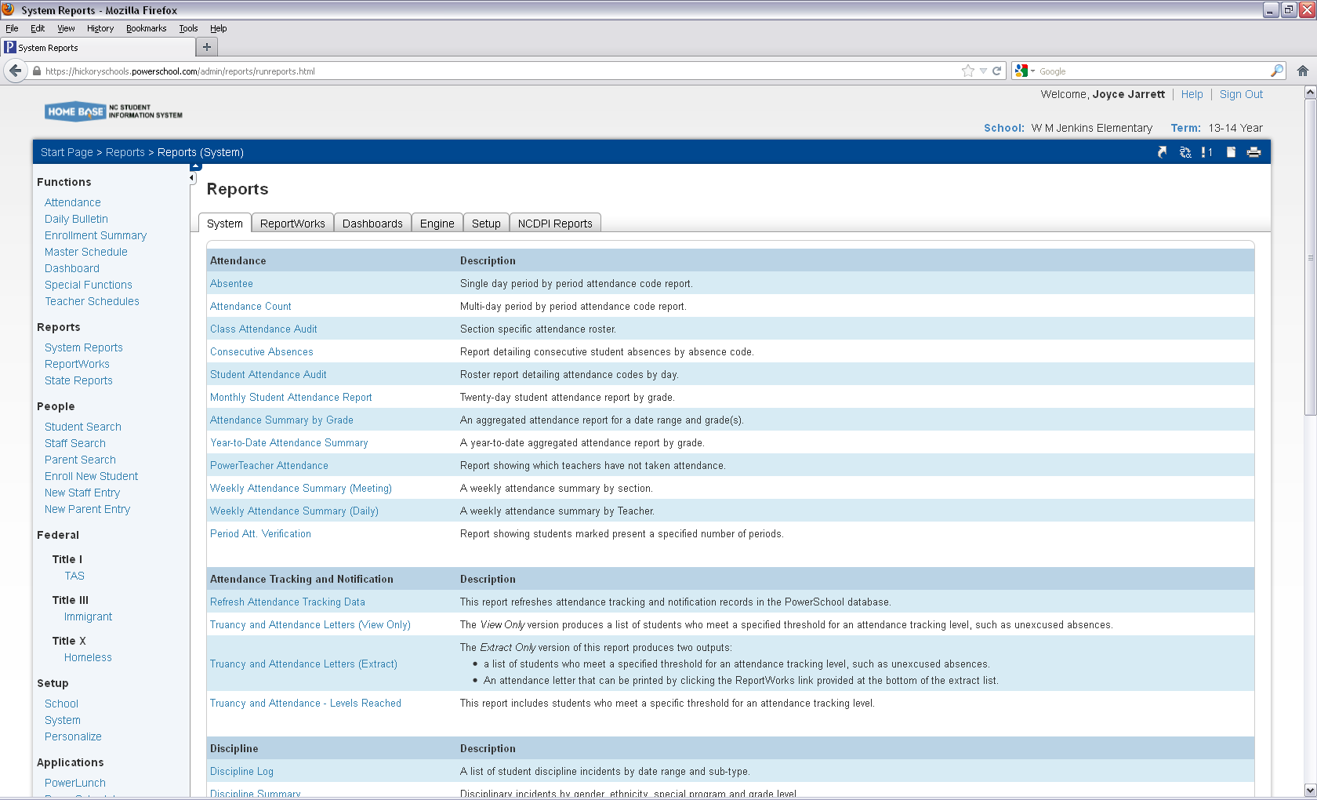

3 Attendance Counts

3

1 Elem, MS change 1 to Daily

2 You can choose a specific grade or choose all

3. You can choose all codes. Specific codes such as suspension or unexcused absences.

More than 1 control and highlight.

4. Fix your date range.

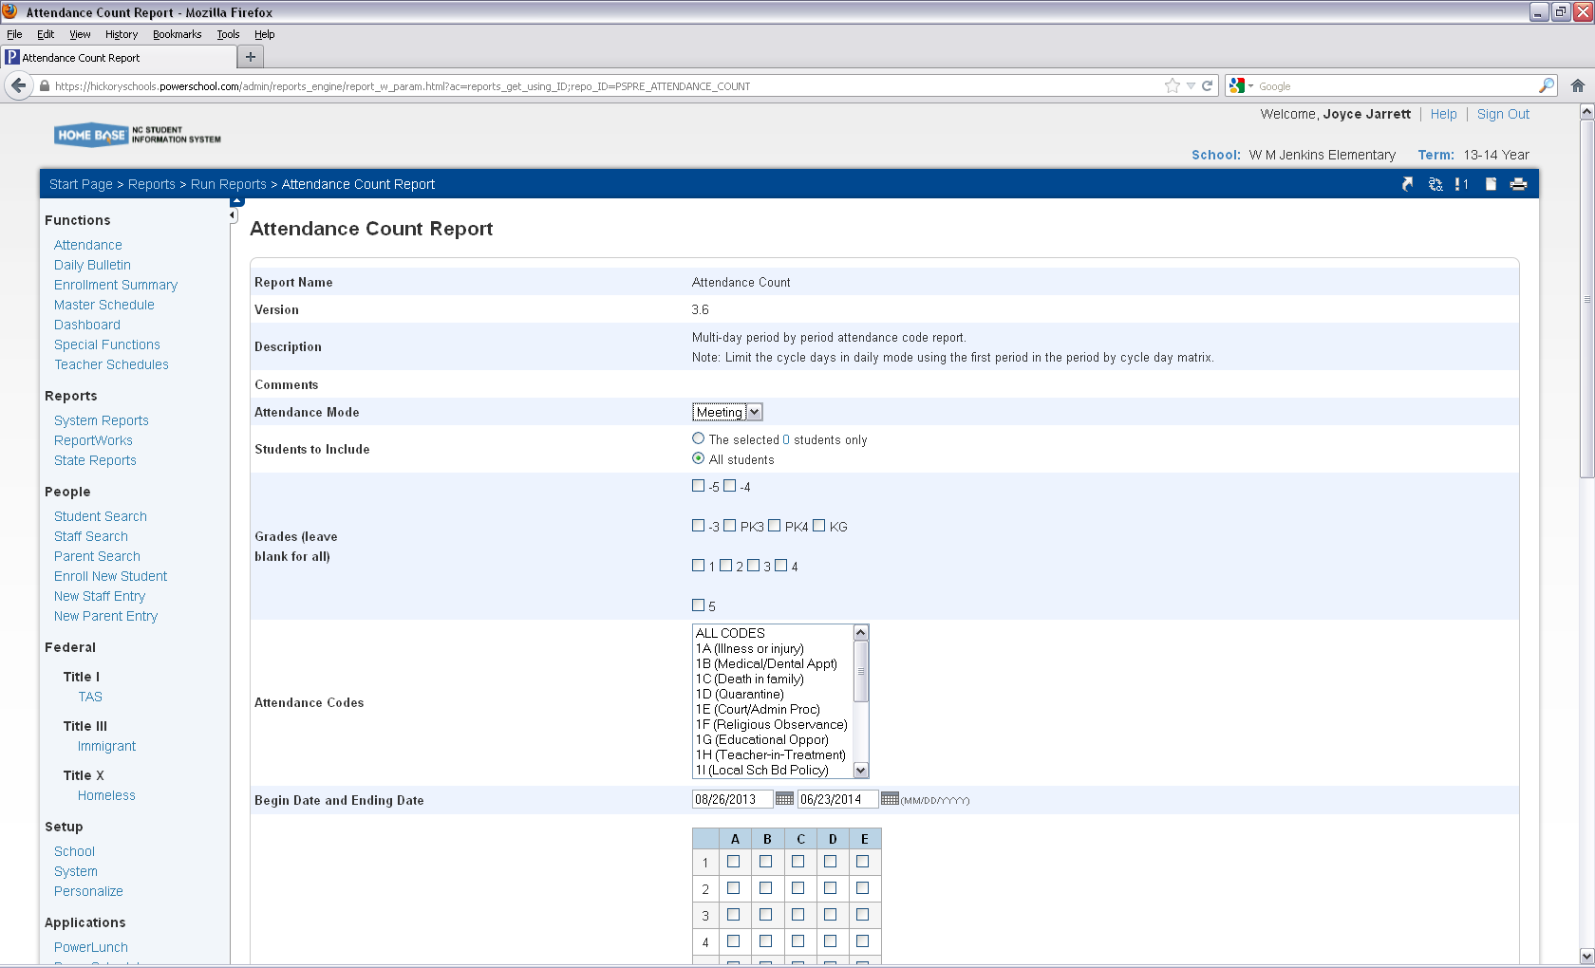

4

Codes

2

1

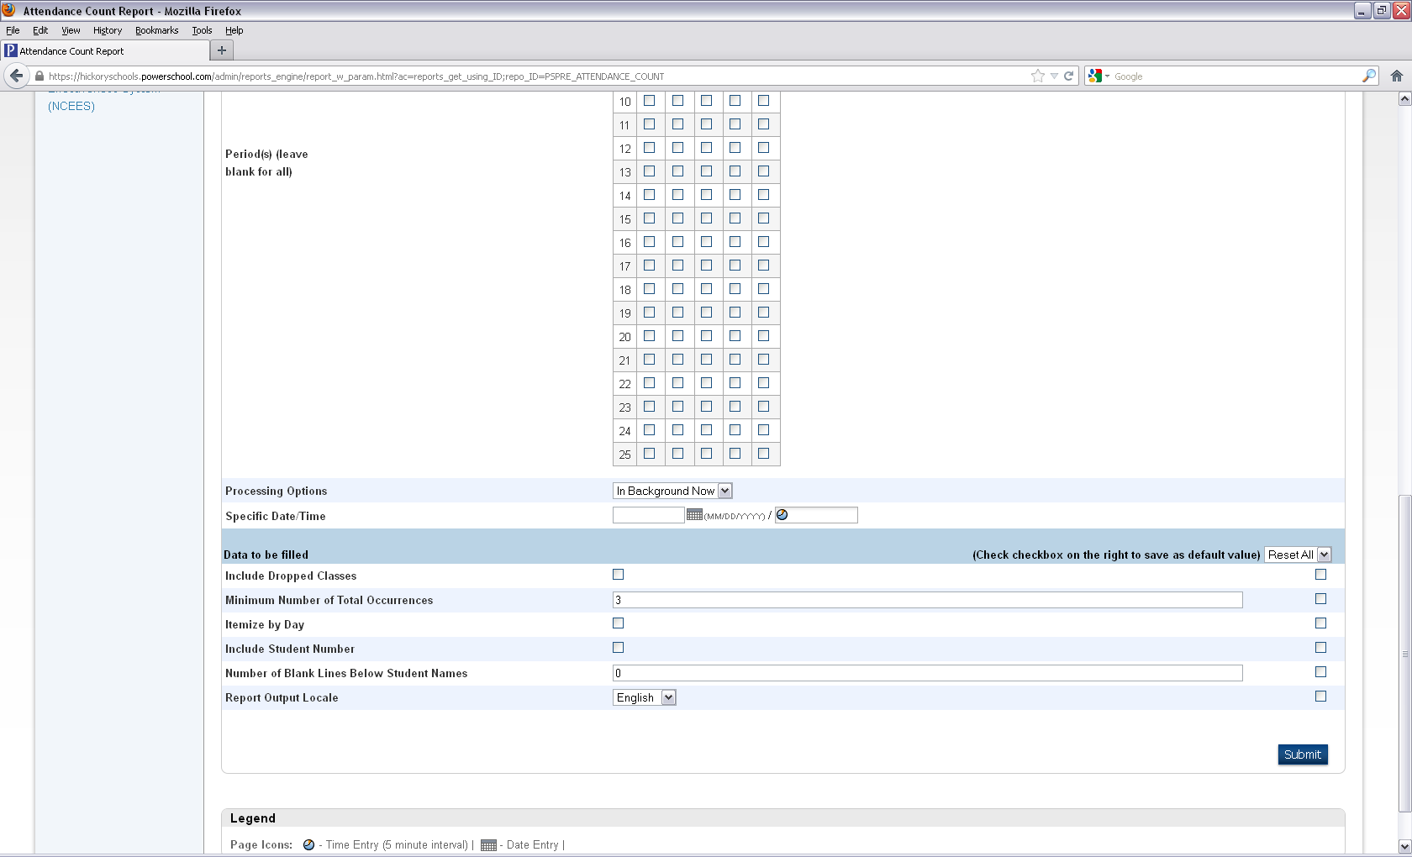

7 Report finishes and you right click on the view and open in a new tab.

Below report I requested all and the codes and totals show students with absences. You could compare with your perfect attendance.

6

5

5. Elementary, MS will not choose a period.

6. You need to make 1 for

Information you need every

Detail. Such as you are running report for suspensions.

If you need more than 6 un excused absences then type in 6.

Submit

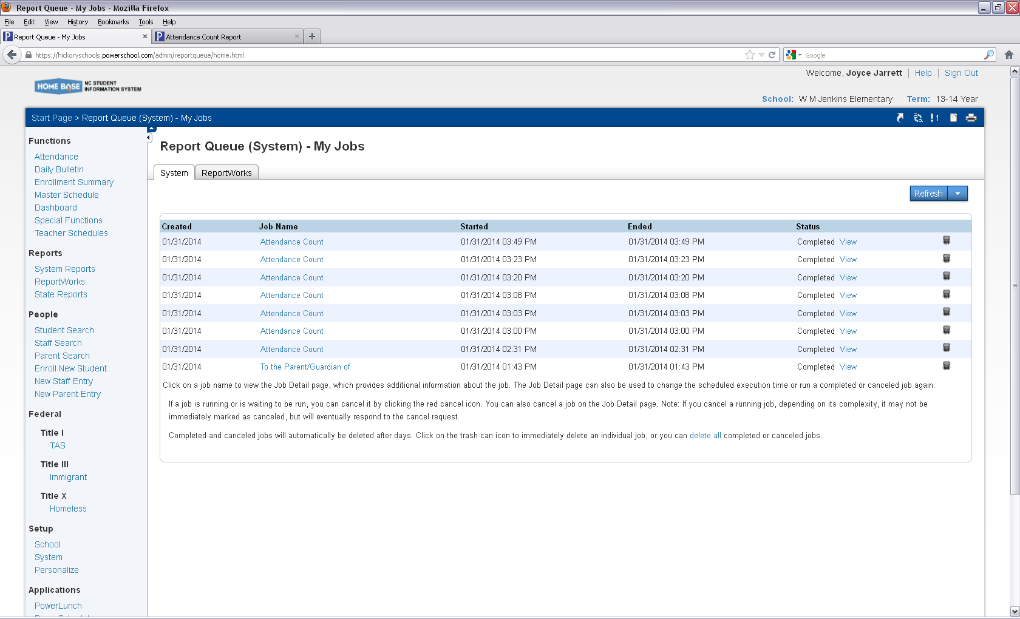

7

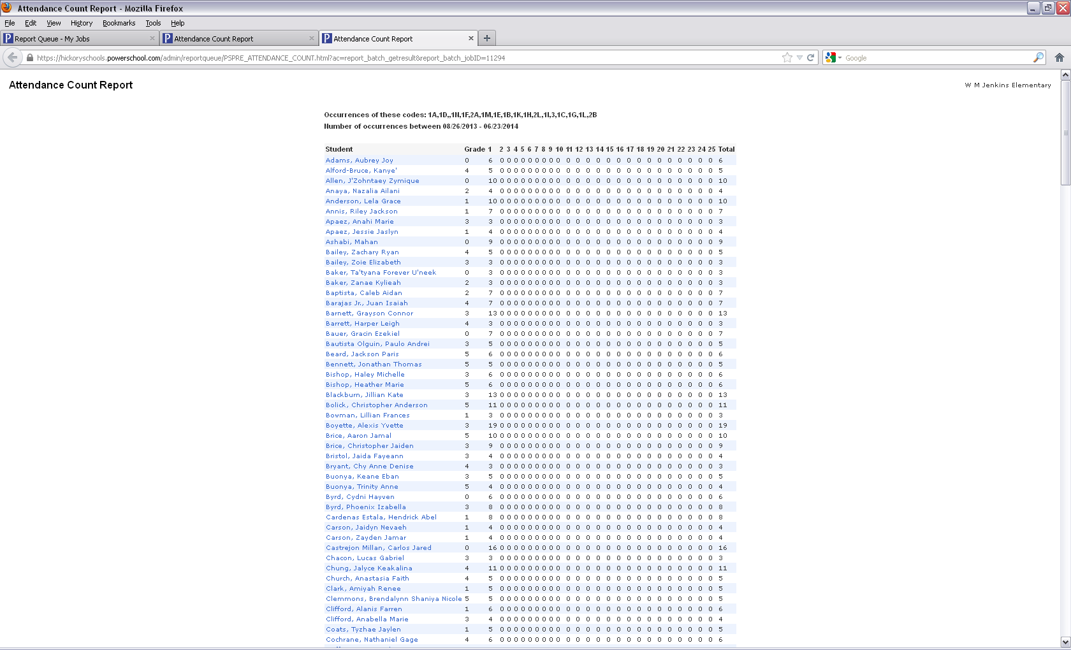

At the bottom of the screen you can choose the functions which will allow you to print letters or labels.