Section Readiness Report
Click on PT Administrator from the start page.
The grade book application will open in a new web site.
Hoover over the Reports. Section Readiness Report will appear. Click on the name
Click here

Section Readiness Report Will Appear. You will need to change some information.
In order to run the reports.
Choose Both
Choose the reporting term you are working in.
year
Choose completed, not yet, or all
comcom
Choose your school
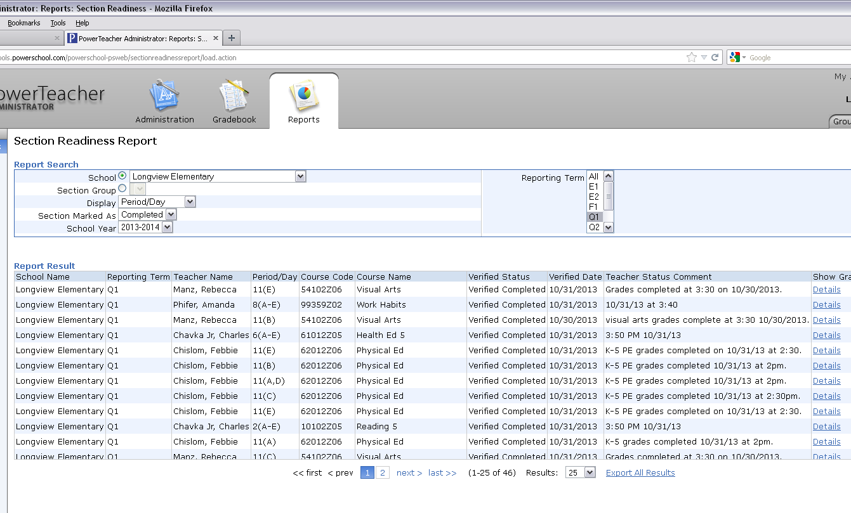
In order to check all that finished you can click export.
Open with excel
After Teacher clicks complete you will
See verified complete and teacher will add “comment completed”

To be able to look at or export click on Details
School name
Teacher names listed here
When everything is complete you will be ready to store grades.

