T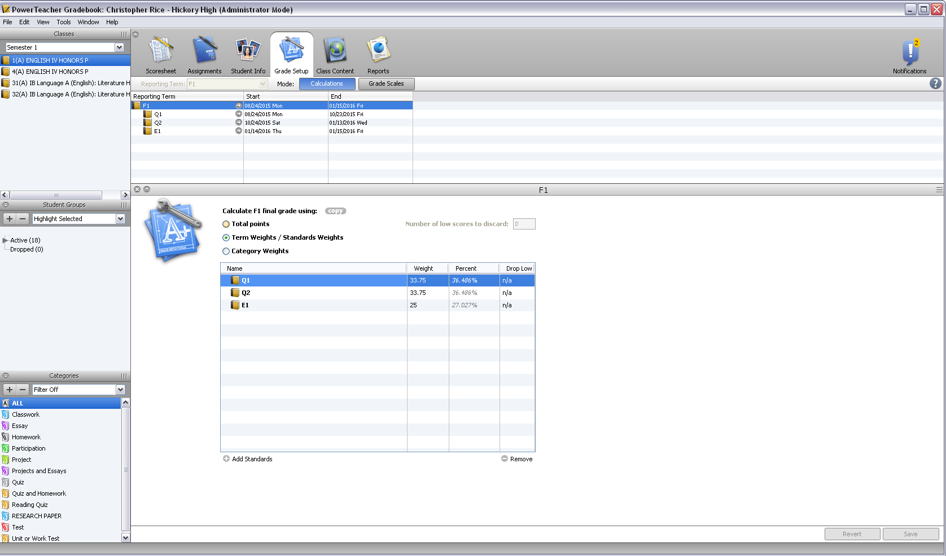

Tools

Recalculate Final Scores on the drop down

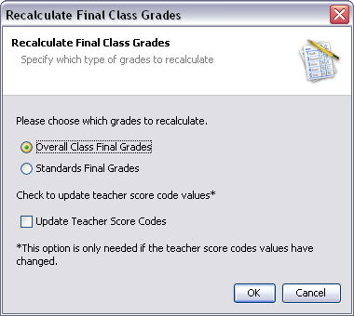

Overall Class Final Grades

OK